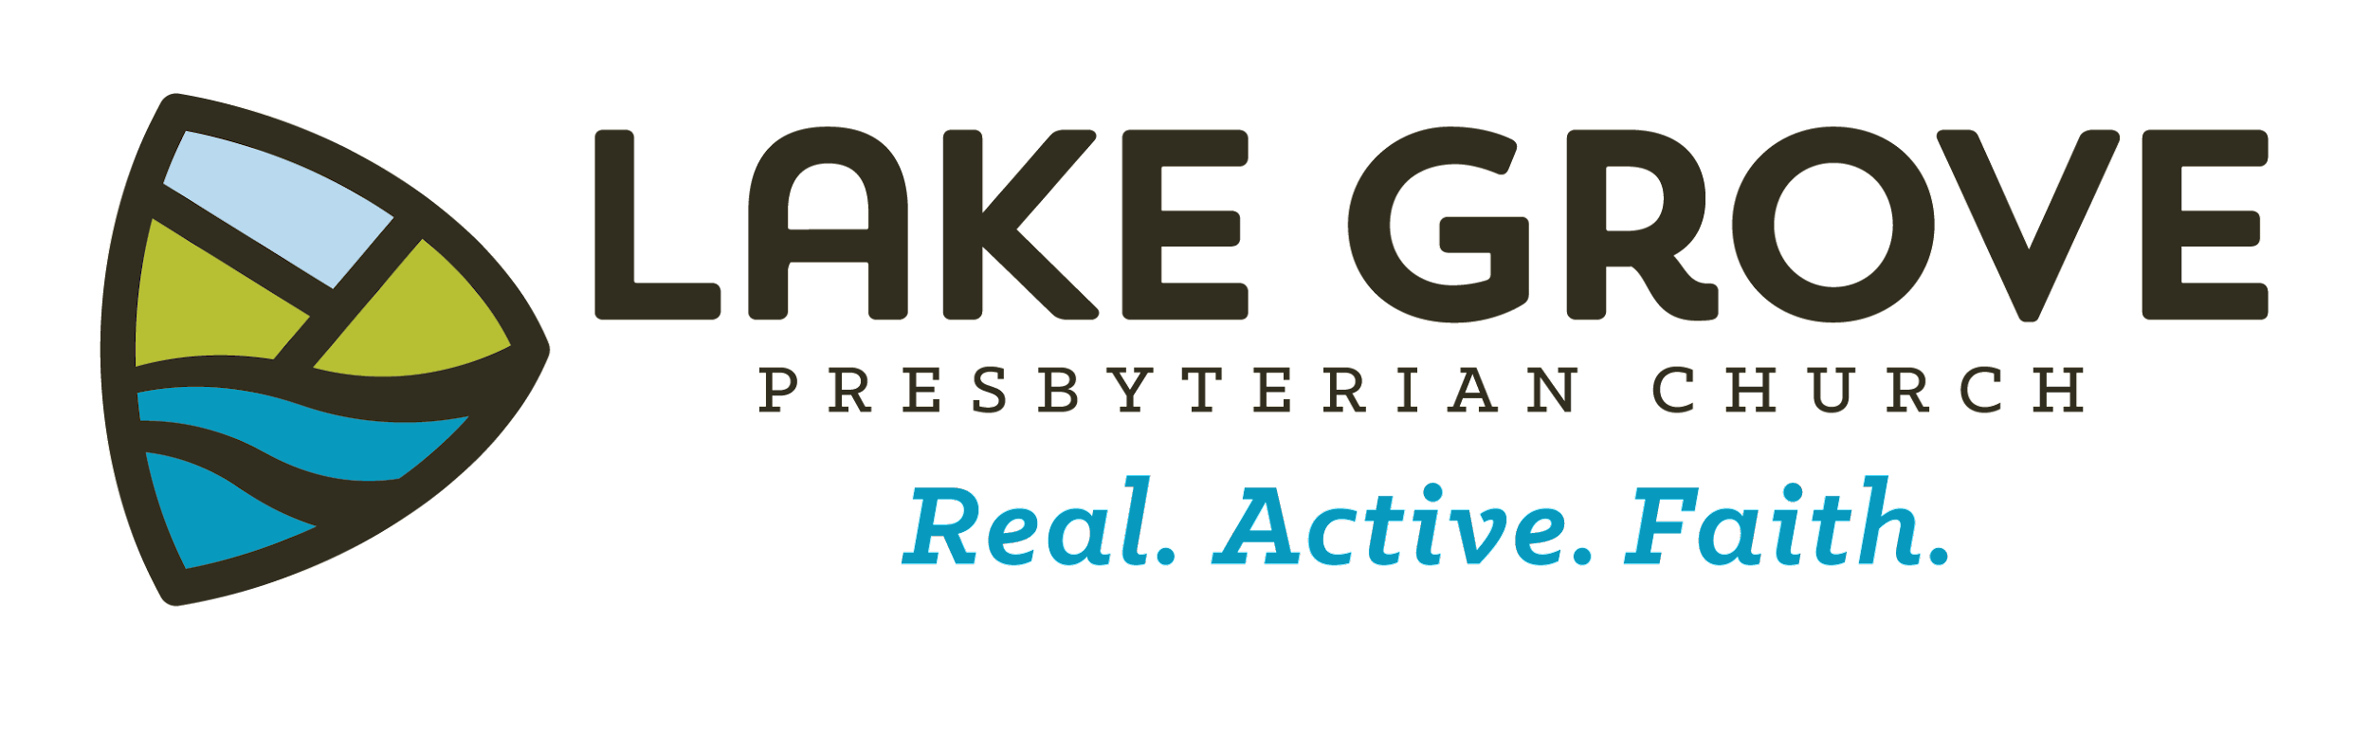 | Children & Youth Ministries  RELEASE & REGISTRATION FORM

Today’s Date:

Student’s Name:

Address: City and Zip:

Date of Birth: Grade in Fall 2022: School:

Primary Family Phone: Student’s Cell Phone:

Parent/Guardian Name: Work or Cell Phone:

Parent/Guardian Name: Work or Cell Phone:

Primary Household Email:

Student’s Email:

Student’s Instagram:

Please share any special considerations or allergies that would be helpful for us to know:

CHECK APPROPRIATE BOXES, THEN SIGN BELOW:

Consent for Social Media Contact (Youth Ministries): I hereby (please check appropriate box) ❑DO ❑DO NOT give permission to Youth Ministries staff to contact my child through social media networks (Facebook, Twitter, Instagram, etc.).

Consent for Photography: I hereby (please check appropriate box) ❑DO ❑DO NOT give permission for a church representative, employee, or volunteer to take pictures and/or video of my child. Pictures may be candid or posed and will be used for a variety of communication and identification mediums to include, but not exclusively, such things as brochures, databases, slideshows, LGPC website, and posters.

COVID-19 Agreement: COVID-19 is highly contagious and is known to spread mainly from person-to-person contact. By attending a Lake Grove's Ministry activity, you agree to abide by the procedures established by the church to protect attendees and staff, and you voluntarily assume the risk that you and/or your family may be exposed to or infected by COVID-19 either at the church, and/or outside of the church when gathered together. By signing below, you agree to assume all the risks of attendance and participation for you and your family, and you waive any liability against the church and any other parties. If your child or any members of your family are sick and experiencing the following symptoms (Fever, Cough, Shortness of Breath/Difficulty Breathing) you will not send your child to group activities. Please contact your medical provider for any questions about your illness symptoms, and to determine the safest way for you to receive medical care if it is needed.

Medical & Liability Release: By signing below, I authorize paid or volunteer program staff of Lake Grove Presbyterian Church to obtain emergency medical care for my child if I (parent/guardian) cannot be readily reached in an emergency. I also agree that neither Lake Grove Presbyterian Church nor its trustees, representatives, instructors, or agents may be held liable in any way for any occurrence in connection with my child participating in a LGPC activity and I indemnify and hold LGPC harmless from any such claim.

________________________________________________________________________________________________________
Parent/Guardian Signature Date

RETURN COMPLETED FORM TO LAKE GROVE CHURCH LAKEGROVEPRES.ORG Rev 05/2022

